Instructions for importing blogs from Sitebuilder to Webmanager.

Requirements:

You must have access to svn:

Steps to Follow:

1. Paste the code from the below link into the Javascript file on the editor

<https://docs.google.com/document/d/1sJ18DY9IsV9aMx2ec2OXzAUtkbO0l89llTZVLmR8SmQ/edit?usp=sharing>

1. Go to the sitemap page in the editor or build website. The code will automatically start to run.
2. Inspect the page and open the console. You will see the urls of the blog posts being displayed and once the code is done running, it will output the blogs in xml format in the console.

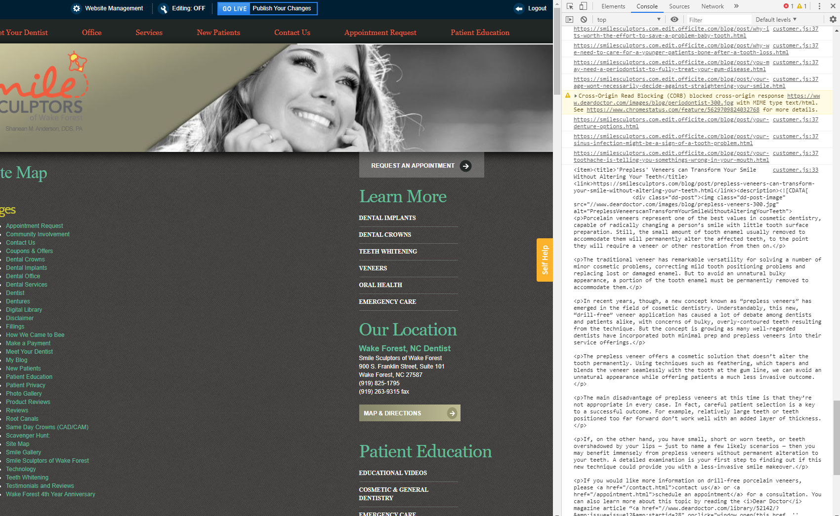

1. Copy the xml code that is outputted. You can either highlight everything or, if it is long enough, a copy button should be available.

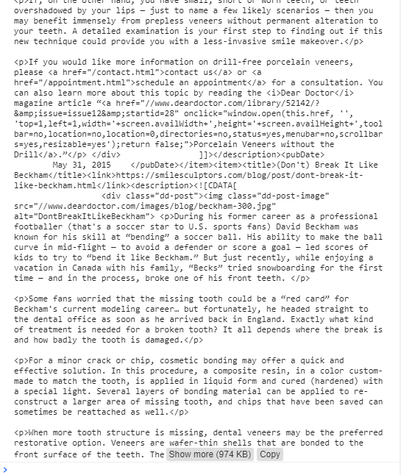

1. Open notepad and paste the output into the file.
2. Save As the file and name it something else. The Save as Type should be All Files (*.*). This file will be opened in a web browser so make sure it doesn’t have spaces. (Example: new_blog_rss.xml)
3. BEFORE YOU CLICK SAVE: make sure to set the encoding to be UTF-8. If you don’t the file will not be able to be processed correctly by the importer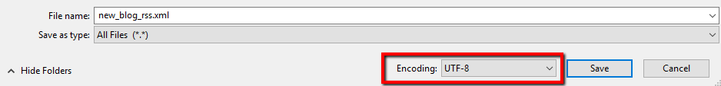
4. Upload the file to the Upgraded Website Webmanager Media Manager
5. Open the xml file in the media manager. Just click on the file in the media manger and next to “Public Url” click “Click Here”
6. The file should look like this when opened

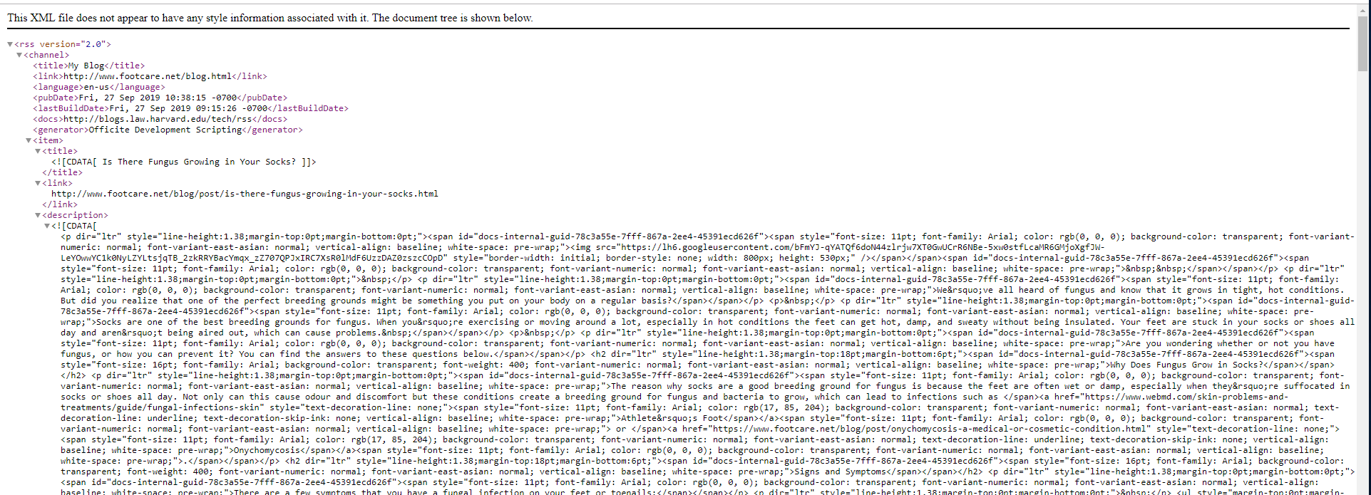

If the file looks like this instead:



Then either the xml file wasn’t saved as UTF-8, or a wierd symbol was imported into the file. Open the xml file, go to the line and column listed and see what the error is.

1. Go to the portal, and click on “Manage Applications > Blog > Settings > Import Blog”
2. Copy the xml url into the text field, and click import
3. May take some time but when it is finished it will say “Unspecified news imported”. This will let you know when it is done.
4. Follow these instructions for setting up the blog redirects  
   <https://docs.google.com/document/d/1CjODvxEAudFHIsC24I-vQAwkkOD9AWu26ksHOUHLs5E/edit?usp=sharing>

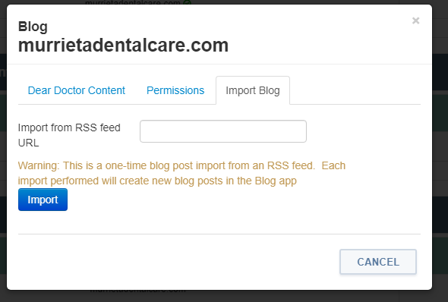

1. This may take a while, but when green text appears that says news has been added it will be done. The blogs should now be imported, you can view them in the portal.
2. Don’t forget to remove the code from the javascript file. While the code won’t break the website, it might slow it down on the sitemap page. Better to just remove it.